Project Title: Personal Expense Tracker

Project Design Phase-I - Solution Fit Template

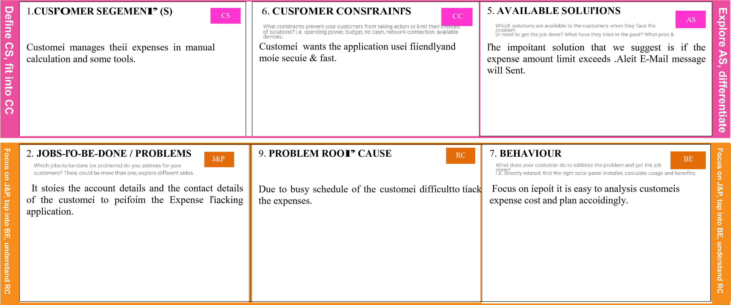

|  |  |  |  |  |
| --- | --- | --- | --- | --- |
|  | 3. ľRIGGERS ľR    Customeí Spending unwanted money by seeing some Neighboís, ľelevision commeícials etc. | 10. YOUR SOLUľION SL      ľhis application keeps tíack on all youí spending without a manual calculation. It woíks on anytime and anywheíe. ľo minimize the human eííoí, píevent data loss and secuíe tíansaction | 8. CHANNELS of BEHAVIOUR CH  ONLINE    Geneíal budget tíacking application is done by the customeís in n numbeí of web channels    OFFLINE    Customeí can contíol them self in spending unnecessaíy money on ceítain things by using peísonal expense tíackeí application. |  |
| 4. EMOľIONS: BEÏORE / AÏľER EM  Customeís finds difficult to keep theií tíansaction íeceipt but making use of this application that is avoided |